**GIT CHEAT SHEET**

* git init 🡪Create Local Repo
* git add . 🡺 All file will send staging area yasin
* git add **filename**: Send file from working directory to staging area
* git rm –cached **filename**: un-stage the file
* rm -rf .git 🡪 Delete Local Repoh
* git status 🡺 Shows status of files in local repo and staging area.
* git branch **branchname** 🡺 Create a branch
* git checkout **branch name** 🡺 Pass to another branch
* git branch -r 🡺 Shows the branches at remote
* git branch -a 🡺 Shows the branches at local and remote
* git checkout -b **branch name** 🡺 Create new branch and go there
* git branch -d **branch name** 🡺 Delete branch (if merge)
* git branch -D **branch name** 🡺 Delete branch force even without merge
* git merge **branch name 🡺**Branch will merge to the present branch
* git commit **filename** 🡺 Send file from staging are to the local repository
* git commit -m **“abc”** 🡺 Commit to file after sending staging area (git add)
* git commit -am **“abc”** 🡺 Commit to file without sending staging area
* git checkout **commitId** 🡺 Change the among commits
* git log 🡺 Shows the commits
* git log –pretty=one line 🡺 Shows commits details in one line
* git log –oneline 🡺 Shows commits brief
* git reset --soft 🡪(Save your changes, back to last commit)
* git reset --hard 🡪(Discard changes, back to last commit)
* git reflog

1a75c1d... HEAD@{0}: reset --hard HEAD^: updating HEAD

**f6e5064**... HEAD@{1}: commit: added file1

* **git reset --hard f6e5064**

HEAD is now at f6e5064... added file1

* git clone **url:** Github repository cloning to the local repository
* git remote add <name> <url> : Send the local repository to the github
* git push: Send the documents from local repository to the remote repository
* git fetch 🡪 git merge: Documents send from remote repository to the local
* **git pull** 🡪 Documents send from remote repository to the local in one step
* git diff 🡪 Show the changes to files not yet staged
* git diff --cached 🡪 Show the changes to staged files
* git diff HEAD 🡪 Show all staged and un-staged file changes
* git diff commit1 commit2 🡪 Show the changes between two commit ids
* git remote -v: Shows the remote branches after fork the others repo

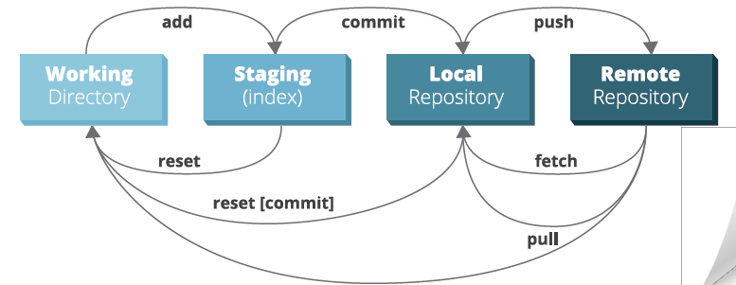

* git - - version: Which version of GIT using
* git config - - global user.name “Yasin Tuten”

Git asking you for your username and password every time:

* git remote set-url origin git@github.com:username/repo.git
* For the Github Token Problem:

Github 🡺 Setting 🡺 Create token.

Copy this token and Go to Control Panel\User Accounts\Credential Manager

You will see there Github and paste this password to there.